
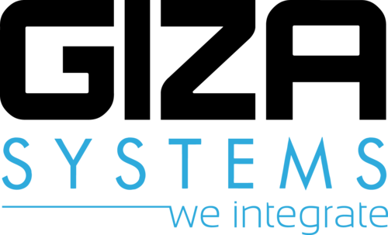

Etisalat/Ericson NOC
Master Test Plan

Template Revision History
Version | Date | Author | Comments
1.0 | 2/10/2012 | Sherif E. Abdalla | Initial Draft
1.1 | 17/10/2012 | Sherif E. Abdalla | Adding more sections

Document Revision History
Version | Date | Author | Comments
1.0 | 16/6/2013 | Mohamed Faisal | Initial master test plan
1.1 | 25/7/2013 | Sherif E. Abdalla | Document review
1.2 | 26/7/2013 | Mohamed Faisal | Apply review comments

Table of Contents

1. Introduction 4
2. Solution Overview 4
2.1 Work Tracking System (WTS) 4
2.2 Work flow management system 5
2.3 Resources Management System (RMS) 5
2.4 Network Management System (NMS) 5
3. Test Process/Phases 6
3.1 Functional/System Testing 6
3.2 Integration Testing 6
3.3 Solution/UAT Testing 6
4. Work Breakdown Structure “WBS” 7
5. Testing Inputs 7
6. Test Outputs/Deliverables 8
7. Out of Scope 8
8. Item Pass/Fail Criteria 8
9. Responsibilities 9
10. Milestones & Schedule 10
11. Staffing 10
12. Trainings 11
13. Approvals 11

Introduction
Etisalat Misr wants to enhance its NOC (network operation center) by Ericson managed services so Ericson hired multiple vendors to develop new tools helping for better time management of the resources, monitoring & statistics of Etisalat’s network elements and performance monitoring for teams team in the NOC.
This document is to represent the master test plan for the whole solution highlighting different testing phases and involved activities with all participating vendors.

Solution Overview
Solution consists of the following systems introduced by each vendor.
HP-Temip | NMS and OMC
HP-uSLAM | Reporting and SLA
HP-SM / HP-AM | Work Tracking System
Ontology | Reporting and topology
GreenPlum | Data Warehouse and Analytics

The Solution consists of 4 systems:

Work Tracking System (WTS)
Work tracking system composed of five main modules:
- Trouble Ticket Manager (TTM): Trouble ticket manager to handle trouble tickets generated by system alarms or other monitoring function such as performance monitoring, or optimization.
- Change Request Manager (CRM): Change requests manager to handle network changing generated by any requestor.
- Work Orders Manager (WOM): Work order manager to direct the field service.
- Customer Support Request Tracking (CSRT): CSRT is a tracking tool aiming to manage CSR creation, modification, tracking and closure.
- Work Tracking Database (WTDB): WTDB is required for knowledge and lesson learned from all occurred issues and changes. The stored data are TTs, CRs, WOs or CSRs.

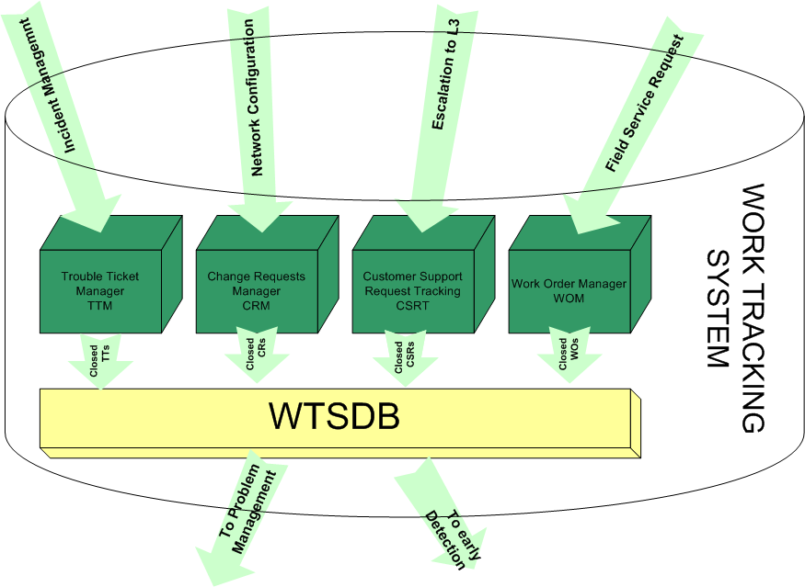

Work flow management system
End-To-End automation that will handle all managed service resources, 3rd party resources, as well as Etisalat Misr teams.

Resources Management System (RMS)
RMS is used for managing field resources including tasking human resources, it includes:
- Work Force Management: Central station receives WO from WOM and directs it to the mobile WOM and directs it to the mobile unit that is held by the concerned field engineer.
- Inventory & Spare Parts Management (ISPM): ISPM shall be integrated to track and manage the spare parts during the service lifetime by tracking inventory in warehouse.

Network Management System (NMS)
NMS is a system that is connected to the live network elements for the purposes of: supervision, monitoring, manage and control and it consists of:
- Supervision System: Supervision system opens a trouble ticket (TT) once alarm toke place then clears the alarm when issue resolved.
- Operation and Maintenance Centre (OMC):
  - OMC shall be connected to all network elements in all domains.
  - OMC users can remotely log in network element for diagnosis and resolution purposes.
- Statistics System (SS):
  - NMS shall contain module for collecting statistics from various network elements.
  - SS shall be able to do deep packet analysis (DPA) per service, so Ericsson shall be able to monitor service statistics per cell to take measures.

Test Process/Phases
Testing the whole solution would include testing every released system from each vendor as a separate unit and after assuring that every system meets customer requirements (both functional and non-functional) the integration among the different systems should take place in order to verify that the end to end solution meets customer requirements & specifications.

Functional/System Testing
In this phase each vendor’s system functionalities are tested against customer requirements as a standalone unit without testing the integration between the system and any other vendor system (integration to element managers is included in this phase)

Integration Testing
In this phase the system integration testing takes place which includes assuring that each vendor system is integrated as requested by the customer to other vendor systems

Solution/UAT Testing
In this phase the solution as a whole is tested against customer requirements and specifications this phase includes the following:
- Functional and non-functional requirements
- Integration testing among different vendor systems

Work Breakdown Structure “WBS”
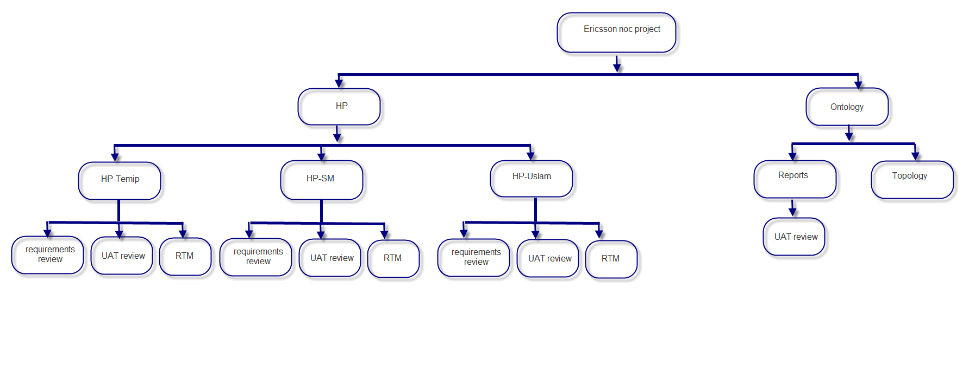

Testing Inputs
Vendor | System/Application | Objective | Needed Input
HP | TeMip | Requirements review | Use Cases
HP | TeMip | Test Cases review | UAT Test Cases
HP | TeMip | Implement RTM | Use Cases & UAT Test Cases
HP | uSlam | Requirements review | Use Cases
HP | uSlam | Test Cases review | UAT Test Cases
HP | uSlam | Implement RTM | Use Cases & UAT Test Cases
HP | SM | Requirements review | Use Cases
HP | SM | Test Cases review | UAT Test Cases
HP | SM | Implement RTM | Use Cases & UAT Test Cases
Ontology | Ontology | Review reports | Ontology requirements document  Ontology UAT test cases
Overall Solution |  | End-to-End acceptance testing | Overall Solution architecture document  RFPs  UAT Test Cases  Use Cases by vendors

Test Outputs/Deliverables
- Master Test Plan.
- Test cases review report for each vendor’s UAT.
- Requirements review report for each vendor’s requirements document.
- RTM for each vendor system.
- Weekly Test Status reports.
- Solution UAT Test Cases specification.

Out of Scope
- Test preparation for every system.
- UAT Test Cases Specification by each vendor.
- Test execution for each vendor system.
- Ontology’s network topology.

Item Pass/Fail Criteria
The following table includes the items to be tested in each vendor provided test case document and its pass and failed criteria.
Item | Description | Pass criteria | Fail criteria
Integration between each system and the assigned element manager | Each system is integrated with some assigned element managers to provide it with network data it will work on and create entities which will have a certain workflow based on customer requirements | All element managers’ integration test cases are passed.  Performance of the data being transferred between the data source and the system in peak workload is accepted by customer | Some element managers’ integration test cases are failed  The performance between the system and the data source in snot accepted by customer
Work flow for the entities having a workflow in each system | There are some entities in each system will be used to apply the workflow simulating the customer manual process | All workflow test cases are passed | Some workflow test cases are failed
Integration among different vendor systems | To complete the cycle as an end to end there is an integration between some systems and each other | All system integration test cases should be passed | Some system integration test cases are failed

Responsibilities
Activity | Responsibility
Test planning | Giza systems
Functional UAT Test Cases Specification | HP , Ontology , OMS
Functional UAT Test Cases review | Giza Systems
Functional UAT Test execution | Ericsson
Functional UAT Test execution follow up | Giza systems
Solution UAT Test Cases Specification | Giza systems
Solution UAT Test Cases review | Ericsson
Solution UAT Test execution | Ericsson
Solution UAT Test execution follow up | Giza Systems

Milestones & Schedule
2013 | May | June | July | Aug | Sep | October | Nov
HP-Temip | Req analysis & sign off |  | Drop1 UAT
HP-Temip |  |  | Design & build drop1 &2
HP-Temip |  |  |  |  | Drop2 UAT
HP-Temip |  |  |  | Integration
Hp-SM | Req analysis & sign off |  | Drop1 UAT
Hp-SM |  |  | Design & build drop1 &2
Hp-SM |  |  |  |  | Drop2 UAT
Hp-SM |  |  |  | Integration
Hp-Uslam | Req analysis & sign off |  | Design , build & UAT
HP-Asset manager |  | Req analysis & sign off |  |  | Design build & UAT

Staffing
Testing resources provided by Giza Systems are as follows:
Resource | Main activities
ES Testing Manager | Overall project control, review plans, suggest test strategies, assist team
Senior Test Engineer | Planning, requirements review, test cases review`
Test Engineer | Requirements review, test cases review, test execution follow up, bugs resolution follow up, status reports

Trainings
It is very essential for at least one of Giza Systems’ testing resources to be included in all trainings provided by different vendors for the operations and support Ericsson team to be able to assist and provide value during the Solution UAT test governance.

Approvals
Approver | Role | Date | eSignature
Sherif E. Abdalla | Head of Testing | 25/7/2013 | SE
Ahmed Sallam | Senior Project Manager
Yasser Sayed | Head of Architects
Mohamed El-Kady | Head of PMs

